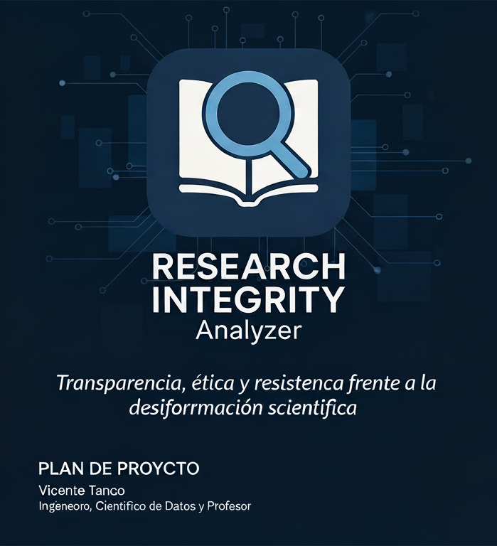
Transparency, Ethics, and resistance against
disinformation

Transparency, Ethics, and Resistance Against Scientific Disinformation

Research Integrity Analyzer

Transparency, Ethics, and Resistance Against Scientific Disinformation

Who I Am
I am Vicente Tanco, engineer, data scientist, and educator, specialized in the ethical application of artificial intelligence and automation for the advancement of knowledge.
My work combines technology, science, and social responsibility, with a clear purpose: to use AI to strengthen scientific integrity and combat disinformation.
After years working on industrial and technological projects, I decided to create the Research Integrity Analyzer as a personal response to the growing erosion of trust in science. The proliferation of unreviewed studies, hidden conflicts of interest, and the media manipulation of scientific results led me to design a tool to restore transparency and rigor in the production of knowledge.
I believe that technology must serve the public interest and protect truth, not distort it. This project merges analytical power with ethical responsibility to identify, measure, and expose potential conflicts of interest in academic publications.
The Research Integrity Analyzer is an extension of my professional and personal commitment to a science that is free, critical, and responsible — a tool built not only with code but with purpose.

Our Mission

To promote scientific integrity and transparency through an automated system capable of detecting potential conflicts of interest in academic publications.

Our mission is twofold:
- Strengthen trust in science, enabling early identification of conflicts before they bias results.
- Empower the scientific community and the public, equipping them with tools to defend truth against manipulation.
We aim to build an infrastructure of accountability that allows researchers, editors, and journalists to evaluate ethical risks in published work with precision and independence.

Progressive Implementation Plan — Research Integrity Analyzer

The development of the Research Integrity Analyzer follows a progressive roadmap that combines applied research, software engineering, and ethical validation. Each phase builds upon the last, advancing toward a fully functional, scientifically validated v1.0 release.

Phase 0 — Launch and Foundation
Duration: 6 weeks
Objective: Establish the project’s technical, communicative, and strategic foundations; build visibility, attract collaborators, and secure initial funding.

Key actions:
- Design project identity (branding, website, repositories, and narrative).
- Publish the frontend + backend proof of concept on Render and GitHub.
- Create an open knowledge repository with public documentation.
- Conduct outreach campaigns across academic, ethical, and AI communities.
- Establish contact with universities, research institutes, and incubators.
- Launch the collaborator and contributor recruitment program.
- Seek initial funding via grants, open research programs, or microfunding.

Key profiles that would add direct value to the project:
- Data engineer / NLP specialist: for semantic extraction and entity modeling.
- Research ethics or philosophy of science expert: for COI metric design and validation.
- Science journalist / communicator: for outreach, storytelling, and impact dissemination.
- Full-stack developer: for backend scalability and PWA/API integration.
- UX/UI designer: for transparent and interpretable dashboards.
- Legal expert in AI ethics and data privacy: for compliance and governance.
- Grant and project manager: for funding strategy and coordination.
- Sociologist or policy analyst: for contextual analysis and open observatory development.

Expected outcome: A foundational team, stable infrastructure, and a coherent public narrative that enables future expansion.

Phase 1 — Proof of Concept (POC): Extraction and Reading
Duration: 4 weeks
- Extract text and metadata from PDFs (title, authors, affiliations, DOI).
- Build /analyze_pdf and /analyze_url endpoints using FastAPI.
- Integrate GPT for initial risk evaluation.
- Deploy working backend and frontend to Render.

Result: A prototype capable of analyzing a document and returning structured metadata and a preliminary ethical-risk report.

Phase 2 — Basic Conflict of Interest System (COI v0.1)
Duration: 6 weeks
- Define risk indicators (funding, cross-affiliations, co-authorship, declarations).
- Design a scoring model (0–100) with low/medium/high risk levels.
- Validate the model with real examples of confirmed COI.
Result: Automated scoring system with a preliminary interpretative report.

Phase 3 — Semantic and Contextual Analysis (COI v0.5)
Duration: 8 weeks
- Integrate NER (spaCy, transformers) to detect entities (authors, institutions, funders).
- Identify co-occurrences and hidden institutional relationships.
- Apply dynamic prompting per scientific domain.
- Add model version tracking and inference logs.

Result: Reports with contextual justification and traceable logic for each risk assessment.

Phase 4 — Scientific Validation and Ethical Review
Duration: 10 weeks
- Establish an advisory committee of ethics and research integrity experts.
- Measure model precision and inter-reviewer agreement.
- Adjust weights and finalize ethical framework.

Result: Scientifically and ethically validated system distinguishing potential risk from actual misconduct.

Phase 5 — Advanced Interface and Reporting (v1.0)
Duration: 6 weeks
- Develop visual dashboards and risk summaries.
- Export PDF reports with ethical insights.
- Add user roles (reviewer, editor, journalist).
- Release public API for integrations.

Result: Fully functional open-access version.

Phase 6 — Open Ecosystem and Continuous Collaboration
Duration: ongoing
- Release core code under open license.
- Build a public dataset of COI indicators.
- Integrate with Zotero, Mendeley, and browsers.
- Create the Open Conflict Intelligence observatory.

Result: A collaborative ecosystem for ethical research analysis worldwide.

Why Conflicts of Interest Matter

A conflict of interest (COI) occurs when scientific judgment may be influenced by secondary interests such as financial gain or institutional pressure. While not inherently unethical, COIs must be identified and managed transparently.

Poorly managed conflicts erode public trust and distort the evidence base.
Industry-funded studies are 4.5 times more likely to produce results favorable to sponsors than independent research.
Identifying these patterns is essential not to discredit science, but to defend its integrity.

An Act of Scientific Activism

The Research Integrity Analyzer is not just a technical project—it is an act of activism against scientific disinformation.
The rise of predatory journals—publications that accept papers without peer review in exchange for payment—has turned the academic publishing system into a market of simulated legitimacy.
These outlets feed misinformation pipelines, providing pseudo-scientific ammunition for media narratives driven by corporate or political interests. The result is a contaminated ecosystem where the appearance of rigor becomes a tool for manipulation.
This project stands as a technical and ethical counterforce. By combining AI and transparency, it seeks to expose financial, institutional, and ideological interests hidden within research, restoring the boundary between knowledge and propaganda.
Every detected conflict of interest becomes a step toward reclaiming truth as a public good.

In Summary

The Research Integrity Analyzer is more than an application:
it is an ethical action in defense of scientific truth.
It protects knowledge as a common good and builds transparency infrastructures to resist the industrialization of disinformation.
My commitment is to use artificial intelligence not to replace human judgment, but to amplify collective integrity.
Transparency is a form of epistemic and social justice.

